**Abstract Template for CMB-Next2020 -International Workshop on the Carbon Materials Breakthrough in the Next Generation-**

**Yuya Kado1 and Toshihira Irisawa2**

1National Institute of Advanced Industrial Science and Technology, Japan

2Nagoya University, Japan

CMB-Next2020 (International Workshop on the Carbon Materials Breakthrough in the Next Generation) will be held in Todaiji Culture Center in Nara, Japan, on **June 27-28, 2020**. In this workshop, we discuss carbon materials in the Next Generation from fundamental to application viewing the carbon materials used in various fields of industry and grasping its very essence. Every speaker is required to prepare a 1-page abstract (A4 size) in English by reference to this template. Please submit your abstract **by April 29** to the symposium secretariat (**cmb-next2020@bunken.co.jp**) as an e-mail attachment.

You can find more information on this symposium in CMB-Next2020 website (https://cmb-next2020.events.gunma-u.ac.jp), but please let us know through e-mail if you have any questions.

We are looking forward to meeting you in the symposium.

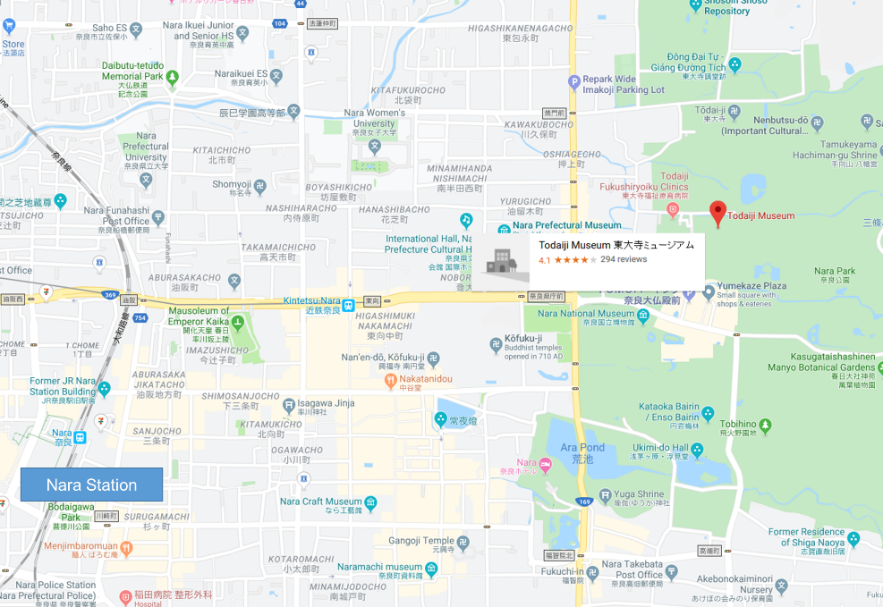

**Fig. 1.** Venue for CMB-Next2020.

**Table 1.** The world heritage site listing for the historic monuments of ancient Nara.

|  |  |  |
| --- | --- | --- |
| Name | Type | Period |
| Tōdai-ji | Buddhist temple | 8th century - Nara period |
| Kōfuku-ji | Buddhist temple | 7th century - Asuka period |
| Kasuga Grand Shrine | Shinto shrine | 8th century - Nara period |
| Gangō-ji | Buddhist temple | 6th century - Kofun period |
| Yakushi-ji | Buddhist temple | 7th century - Asuka period |
| Tōshōdai-ji | Buddhist temple | 8th century - Nara period |
| Heijō Palace | Imperial residence | 8th century - Nara period |
| Kasugayama Primeval Forest | primeval forest | 8th century - Nara period |